Project 2 – Group Essay
Nature as community

We as humans have the most advantageous position in the ecosystem, we are the only species with the ability to improve and benefit from our natural resources. This has undoubtedly led to the preconceived notion of being superior to our environment, this attitude has led to the current deterioration of our ecosystem. Nature is a community that depends on each other’s roles to sustain itself, by taking the sustainability of our resources lightly we are not giving back to the community and that affects our already fragile system. Everyday things that we take for granted, the food we eat, the timber we cut, and the water we draw all amounts to an astounding one-third to one-half of global ecosystem production. The actual function of all these resources when viewed on a larger scale is what sustains not only our species but also our very existence on planet earth. We depend on the benefits that nature provides freely, yet we continue to be ignorant knowing that our resources are irreplaceable.
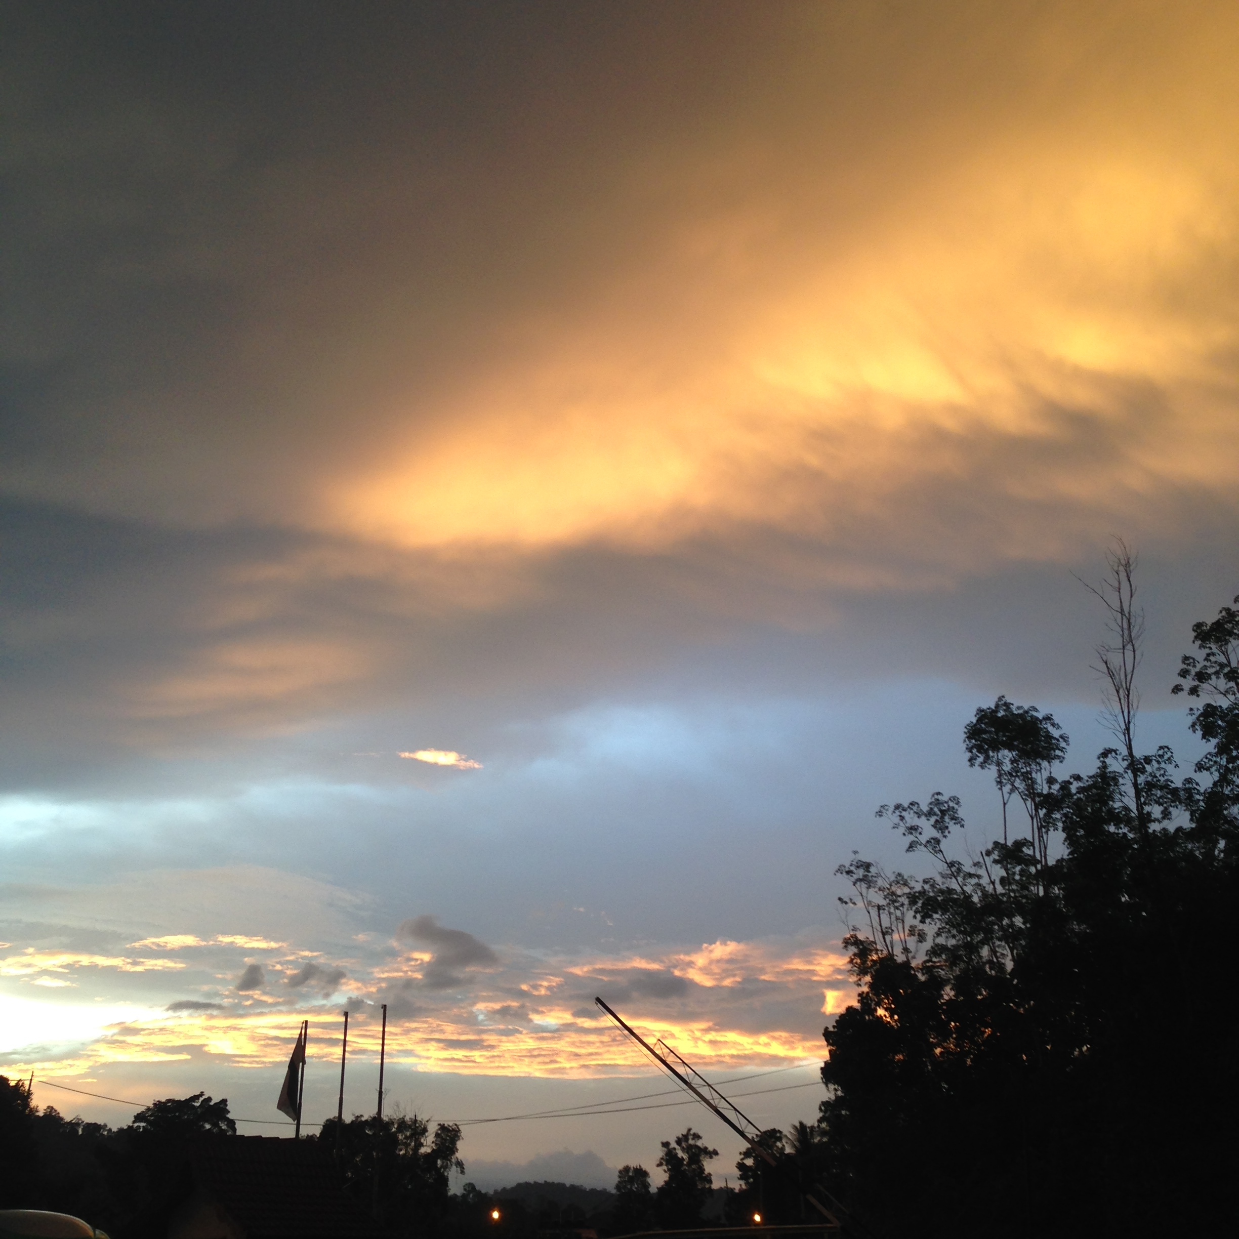
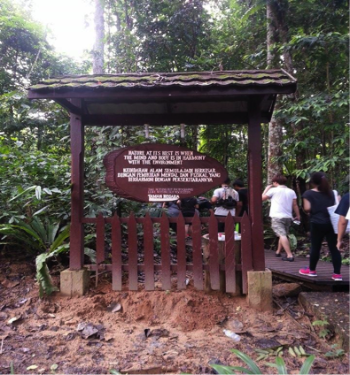

Welcoming entrance sunset nature view

Urbanization is a rapidly growing phenomenon, with all the distraction of modernization humans are getting more and more isolated from nature. As the current younger generation growing up, we are directly affected and it inadvertently shapes our outlook and perspective on nature as an ignorable factor. The trip to Taman Negara forced us in a way to re-experience our natural environment and reconnect with our roots. The experience taught us to open our mind, hence indirectly mobilizing us to start creating a relationship with nature and engage more as a community. Time can be used as a parameter to witness how nature works as a community, for example how day and night alternates and functions simultaneously, the animals that we witnessed during the night walk activity are all part of a nocturnal community whereas we humans are more productive during the day making us part of the daytime community. This experience enlightened us on how nature actually unites us as a community through a sense of time, how these two alternating times contain two communities with separate roles yet they function simultaneously resulting in a combined ecosystem. It also enlightened us on how nature is actually self-sustaining, with different role providers for different times that self adjust to benefit nature according to various aspects.

We embarked on a 2km hike up Teresik Hill leading up to the canopy walk the following day. The guided hike was informative as well as enlightening, the things divulged to us during the hike allowed us to expand our minds towards a new realization. With balance, nature is not only self-sufficient it is also a generous contributor in a community. The hike revealed to us a whole new world of natural resources and their amazingly significant properties. Plants for instance are not only a source of food but also possess a wide variety of uses, ranging from medicinal to hygiene and even home supplies such as furniture or actual parts for building homes. The carica papaya plant’s leaves for example, can be used to treat stomachaches, warts and reduces high fever. In fact it is currently being scientifically studied as a potential cure for dengue. There are a plethora of other plants with medicinal properties that can be found in the jungle, like the Senduduk Hutan as it is known locally which acts as a natural antiseptic and can stem blood flow from minor wounds. Useful should one not have a first aid kit handy, or the Trevesia Burckii or “Tapak Hantu” in malay, that can restore energy and also acts as apparently, an aphrodisiac. Others had cleaning and refreshing properties, like the Beluru root which produces foam when water is added that acts much like soap or shampoo and can be used as both. Cosmetic products can also be found in nature in the form of varying shades of hardened clay, small bits of these colorful pieces of clay are mixed with water producing a natural pigment that can then be applied. The indigenous Batek tribe of Malaysia uses this natural clay pigment as makeup for occasions such as their wedding. Apart from topical uses, there are also a variety of plants that can be used as building materials or furniture such as rattan or bamboo. Also provided are survival essentials, such as resin from various trees used as kindling/tinder to start fires and water vines, roots and fruits that contain drinkable water. Nature does not only cater for your health and survival, it also expends vices for your leisurely use. These are the aspects of nature that our current generation and society are missing out on, if we only learned to apply ourselves to nature. We are too dependent on our vices in the fast paced world we live in that we have not only become ignorant, we have also impacted the younger generation’s priorities and perspective. Nature has provided us with our essentials but it too is interdependent, on us especially because we are the largest consumers therefore we have the largest role. A role we don’t fulfil enough. Yet humans have always had selfish ingrained into them, we exploit and take advantage of our resources like there’s no tomorrow all for the sake of profit. Profitable only to ourselves, nature takes the brunt of the consequences of our greed and we as humans dare to lament about the increasingly hostile environment we brought on ourselves. Sustainability creates and maintains the conditions under which humans and nature can coexist productively and harmoniously, this requires fulfilling the social, economic and other needs of present and future generations. Prevention is better than cure, if it’s too late for us then we should educate and instil sustainability in the young so it’s importance will register.

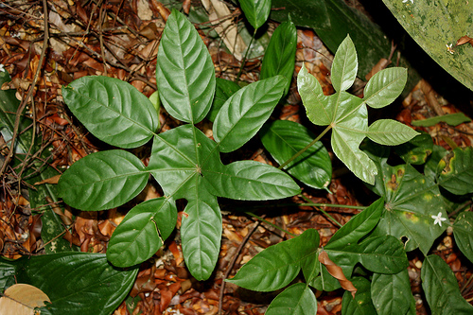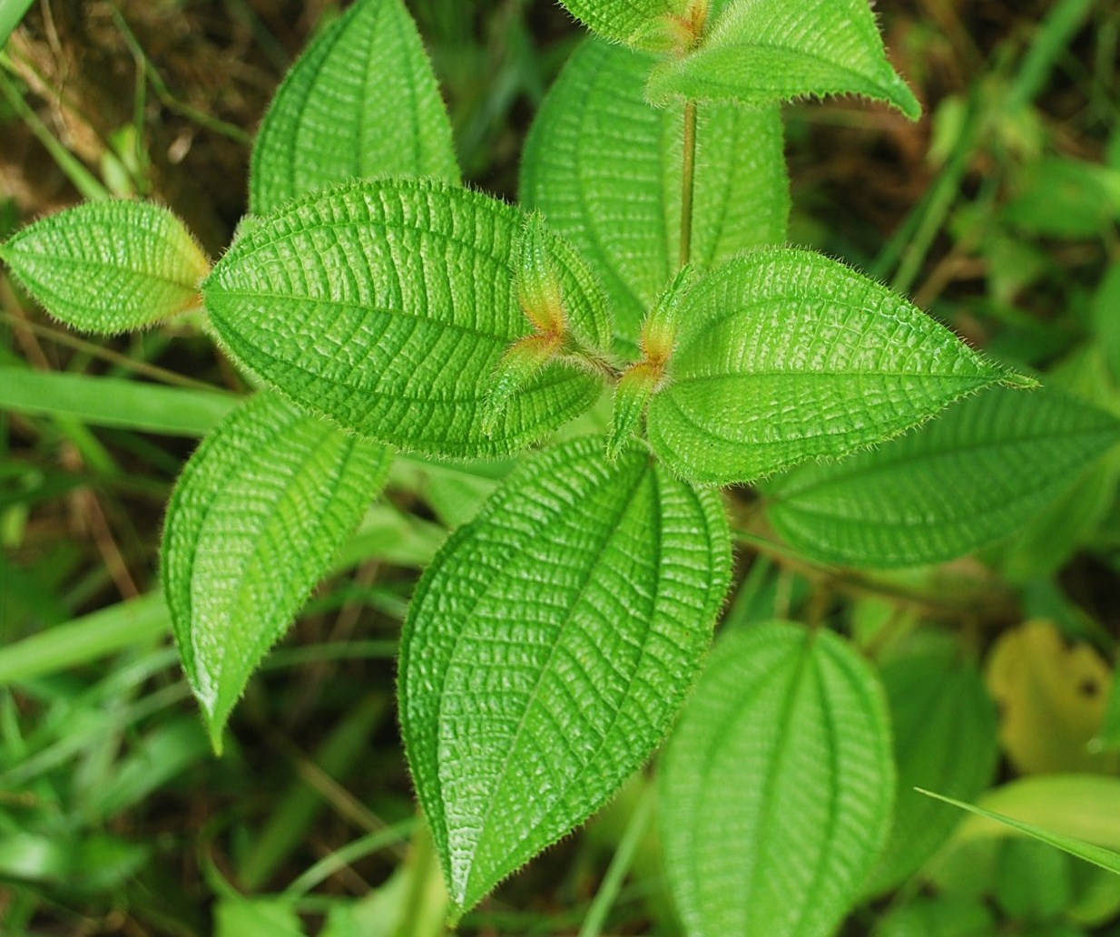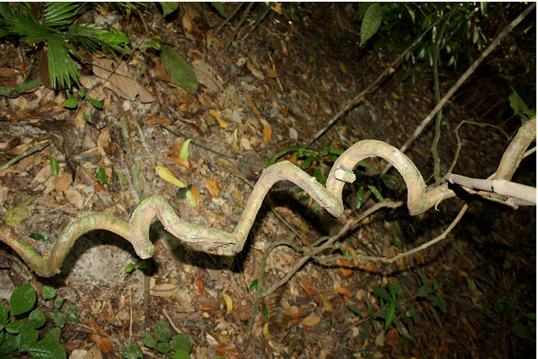
some of many plants with unique characteristics

Society is always driven to success, children in school are taught basics to being successful. Everyone is focused on the same things, that perspective is affected. Sometimes we need to take a step back and view the bigger picture to appreciate and value what we have. The same goes to nature, from the great height of the canopy walk we were afforded an astounding view and literally gained a larger perspective altogether. The structure of the canopy walk was an amazing feature, the entire 500 meters of the canopy walk is supported and constructed without the use of a single nail or other modern reinforcements. The only structural support employed throughout is the clever use of rope and wooden joint techniques, this is to protect the trees and surrounding environment from any possible damage. The height also elevated our feeling of being one with nature, and we were able to view how nature flows seamlessly (resources & aesthetics) into itself, and that in itself is the beauty of nature.

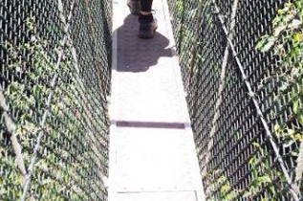
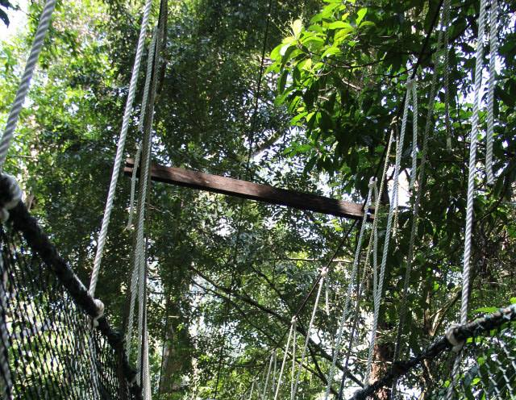
natural view from canopy the canopy walk

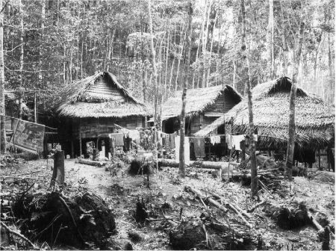
Often when we feel depleted, we reach for a cup of coffee, but to the Orang asli, Nature is their daily booster. They consistently rejuvenate themselves by embodying nature or just by imagining themselves in such situation. These people are actually people we should learn from. The Orang Asli integrate themselves with nature not just by engaging with it, they fully utilize the resources nature gave them. For instance, they craft their own hunting weapons out of bamboo to produce a blowpipe. The blowpipe consists of a rubber insulator as a mouthpiece made out of melted tree sap to regulate air pressure, the shaft and sheath/casing from bamboo poles and the darts out of rattan with a lightweight piece of root attached to the back for balancing purposes. The darts are then dipped into natural toxins derived from various plants according to lethality. They also make their own fire out of a mechanism where two different pieces of wood with different textures rub against each other. Not just that, the Orang Asli hang their dead on trees and wrap the corpses in huge leaves to deter wild animals. The contact between nature and communities has also encouraged more women to take part in decision-making. While the men hunt for food, the women built the house, the houses are very natural, nomadic, and degradable designed house. It is built out of huge leaves and rattans. All these simple things nature provide them are their treasure, which we often underestimate and put aside. We all have natural connection with living things, Nature is something within which we flourish, it’s just the matter of who can appreciate and treasure nature as a part of themselves. And these Orang Asli had shown us how having nature to be part of our life is critical, regardless of where we live either in a village or in a built in environment, we are all one as a community with nature.
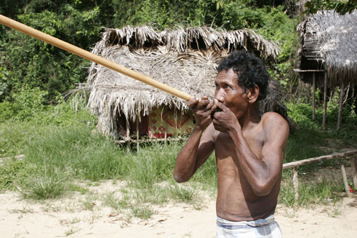
orang asli typical houses demonstrating blow pipe

Humans are inevitably connected to nature, this is evident in our need to incorporate nature in our daily lives(i.e. lawn, garden, etc.). The relationship between people and nature is dynamic, interactive, and complex. Humankind has not always understood its relationship to nature in the same ways, for we come from many cultures and experiences that continuously change over time. Nevertheless, we are all part of nature, and our physical beings are comprised of many of the same elements and rhythms that make up the world around us. Yet, while we are part of nature, we also see ourselves as distinct from it, standing outside if not above the rest of the natural world. We often take and hardly give. Not only are we a dominant life form, we have this amazing ability to extract rocks and liquids and gases from the Earth and to burn them. We have the ability to push land around, to remove mountains, to build islands, and to manufacture concrete. Without noticing that our nature is at their critical state and in need of our help and unite as a community. No matter the task in which people engage, we are bound to nature and nature is bound to us. By taking more than giving, we are disrupting the cycle therefore we become parasitic and need to give more to the community of which we come from. Nature should not be alone in it’s time of need with such capable participants as us in it’s community. We need to come to our senses, before we render our selves, and our planet to nothingness.

References
(2014). Retrieved from http://anailzda.files.wordpress.com/2012/01/laporan-ekspedisi-ke-taman-negara.pdf
Blogs.dickinson.edu,. (2014). Nature as Community: Long « Human Place in Nature Fall 2013. Retrieved 26 June 2014, from http://blogs.dickinson.edu/humanplaceinnature2013/2013/10/14/nature-as-community-long/
Depankanta.blogspot.com,. (2012). depankanta.blogspot.com: SYAMPU AKAR BELURU. Retrieved 26 June 2014, from http://depankanta.blogspot.com/2012/10/syampu-akar-beluru.html
Noor, R. (2011). Suria Helang Lui: March 2011. Suria-helang-lui.blogspot.com. Retrieved 26 June 2014, from http://suria-helang-lui.blogspot.com/2011_03_01_archive.html
Rimbundahan.org,. (2014). Rimbun Dahan -- Plant List of Taman Sari/Herb Garden. Retrieved 26 June 2014, from http://www.rimbundahan.org/environment/plant_lists/taman_sari/
Wikipedia,.(2014). Caricaceae. Retrieved 26 June 2014, from http://en.wikipedia.org/wiki/Caricaceae

